Revised Activity 1.1.5 Your Sci-Fi Name

Subtarget 1.4: Use the Math.random method to generate random numbers, including generating random integers within a given range

Stan Lyakhov

I will look at the 3 conclusion questions.

Introduction

Have you ever wondered where science fiction books and movies get those strange, alien names for their characters? It is possible they used a computer **algorithm**. In this activity, you will create a science fiction name for yourself using the string methods you know and a new method you do not yet know.

Materials

* Computer with BlueJ

Activity

Part I: Random Numbers

Part of the algorithm for generating your science fiction name will involve the use of random numbers. Random numbers are like rolling the dice—you never know what numbers you’re going to get. Chatbots also use random numbers to give unpredictable responses to questions or to ask random questions themselves.

To generate a random number in Java, you will use a method from a new class, the Math class. The method you will use is random():

Math.random();

To assign a random number to a variable, you will use:

double r = Math.random();

The Math.random() method generates a number from 0 to .999999999999999. This is a versatile algorithm that allows a programmer to generate a wide variety of random number values. For example, if you multiply the random number returned from Math.random() by 10, you would get random numbers between the values of 0 and 9.99999999999999. If you cast this value to an int and add 1 to the result, you will get a random number between 1 and 10.

1. Review the online documentation regarding [**Random Numbers**](http://interactivepython.org/runestone/static/JavaReview/VariableBasics/randomNumbers.html) and complete the “Check your understanding” exercise. How would you call or invoke a static method called sqrt(25) that is part of the Math class?

Math.sqrt(25)

1. Explain how the following call simulates a dice roll.

int diceRoll = (int)(Math.random() * 12) + 1;

A number (12) is multiplied by a randomly generated number from 0 to 0.999999 (which results in a number between 0 and 11.999.) it is then casted to an integer and 1 is added to create a number between 1 and 12. Similar to the roll of a 12 face dice

Part II: Your Personal Science Fiction Name

Your science fiction name will be generated using a combination of String methods, random numbers, and concatenation. All input to the algorithm must be at least three characters long, and for best results, use lowercase letters with no spaces.

1. Get a copy of 1.1.5SciFiName_StarterCode_BlueJ from your teacher. Extract or copy the files to your BlueJProjects folder and open them in BlueJ.
2. Open the SciFiName class and briefly observe the code. You have also been given a class called UserInput that gathers input from a user. Feel free to review this code; just know you will not be required to modify it.
3. At the end of the main method, you will see a comment that says // generate a SciFi name. You will add all of your code below this comment.
4. Your first Sci-Fi name will be generated using the following algorithm:
   1. Using the indexOf and substring methods, get the first *three* letters of your first name.
   2. Similarly, get the first *two* letters of your last name.
   3. Using concatenation, combine these results to generate your Sci-fi first name.
5. Likewise, your Sci-fi last name will be generated using a similar algorithm:
6. Get the first *two* letters of the city you were born in.
7. Get the get the first *three* letters of your elementary (or previous) school.
8. Using concatenation, combine these results to generate your Sci-Fi last name.
9. Your Sci-Fi place of origin will be more randomly generated and will extract letters from the end of a name:
10. Generate a random number between 1 and (length – 1) of a relative’s first name. For example, the result may be 2 as shown in the table:

|  |  |  |  |  |
| --- | --- | --- | --- | --- |
| E | d | i | t | a |
| 0 | 1 | 2 | 3 | 4 |

1. Get the last letters of your relative’s first name beginning at the random location through to the end of the string.

|  |  |  |  |  |
| --- | --- | --- | --- | --- |
| E | d | i | t | a |
| 0 | 1 | 2 | 3 | 4 |

1. Generate a random number between 1 and (length – 1) of another relative’s name. You may choose to use a friend's name in place of a relative's name.
2. Get the last letters of this name beginning at the random location through to the end of the string.
3. Using concatenation, combine the results from b and d to generate your Sci-Fi place of origin.
4. Print a friendly message such as:

"Hello carki chsal of lesomas. Welcome!"

**Part III: Enhance Your Algorithm (Optional)**

The String class has more methods than you will be required to know and some of them can enhance programs to make them more interesting or fun to use.

1. Explore the [**Java API online documentation for the String class**](https://docs.oracle.com/javase/7/docs/api/java/lang/String.html) and a new method toLowerCase. Convert the Sci-Fi names and place of origin to lowercase letters just in case users enter uppercase letters. Then change the user instructions.
2. Explore the new String method toUpperCase. Along with substring, capitalize the first letter of each Sci-Fi name and the place of origin.

**Conclusion**

1. Show the java code to find a random integer between 2 and 47.

int random1 =(int)(Math.random()*((47-2)+1))+2

same as:

int random1 =(int)(Math.random()*46)+2

1. Explain how the following two statements return different results:

int r1 = (int)(Math.random()) * 10 + 1;

int r2 = (int)(Math.random() * 10) + 1;

In the first one the output of Math.random is casted before the multiplication while the second one is casted afterwards, only the second one works

3. Paste snips of your output (including your inputs!) and the code you created under //generate a sci fi name:

Input/output:

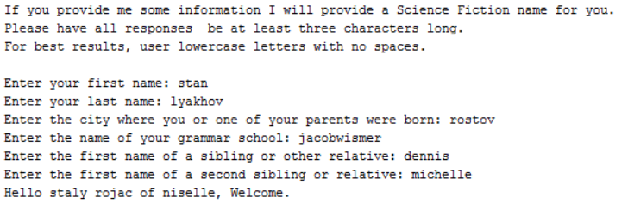

Code:

